CS322 Software Construction



Software Requirements Specification (SRS)
University Scholarship Management System
Case Study #1

PRESENTED BY
Member 1: Ahmed Hassaan Gondal (Lead) (04072313022)
Member 2: Muhammad Arslan (04072113004)
SUPERVISED BY
Dr. Onaiza Maqbool
Department of Computer Science
Quaid-i-Azam University, Islamabad
October 2026
SRS Document Approval Signatures
Team Lead
______________________ _______________________
Signature Date
Ahmed Hassaan Gondal
Student, QAU Islamabad
Member
______________________ _______________________
Signature Date
Muhammad Arslan
Student, QAU Islamabad

Stakeholder
______________________ _______________________
Signature Date
Dr. Onaiza Maqbool
Professor, QAU Islamabad
Change History

Version No. | Date | Modified  By | Changes
1.0 | 30/09/2026 | Ahmed Hassaan Gondal | Original. Made from our use case document use case diagram and analysis models (Task 4).
1.1 | 07/10/2026 | Ahmed Hassaan Gondal | Updated SRS as per IEEE 830. Add interfaces, UC-01, UC-02, UC-04 and update domain model.
1.2 | 07/10/2026 | Muhammad Arslan | Add UC-05 to UC-08, performance and quality requirements, data dictionary and design constraint.

Remarks

____________________
Signature

Dr. Onaiza Maqbool
Professor, QAU Islamabad
Table of Contents
1 Introduction 5
1.1 Purpose 5
1.2 Scope 5
1.3 Definitions, Acronyms and Abbreviations 6
1.4 References 6
1.5 Overview 6
2 Overall Description 8
2.1 Product Perspective 8
2.1.1 User Interfaces 8
2.1.2 Hardware Interfaces 8
2.1.3 Software Interfaces 8
2.1.4 Communications Interfaces 8
2.1.5 Memory Constraints 8
2.2 Product Functions 8
2.3 User Characteristics 9
2.4 Constraints 9
2.5 Assumptions and Dependencies 9
3 Specific Requirements 9
3.1 External Interface Requirements 9
3.1.1 User Interfaces 9
3.1.2 Hardware Interfaces 10
3.1.3 Software Interfaces 10
3.1.4 Communications Interfaces 10
3.2 Functional Requirements (Use Cases) 10
3.2.1 UC-01: Login 11
3.2.2 UC-02: View Scholarships 12
3.2.3 UC-03: Apply for Scholarship 13
3.2.4 UC-04: View Application Status 14
3.2.5 UC-05: Manage Users 16
3.2.6 UC-06: Manage Programs 17
3.2.7 UC-07: Manage Scholarships 18
3.2.8 UC-08: Advertise Scholarship 19
3.2.9 UC-09: Review Application 20
3.3 Performance Requirements 22
3.4 Logical Database Requirements (Data Dictionary) 22
3.5 Design Constraints 23
3.6 Software System Attributes 23
3.6.1 Reliability 23
3.6.2 Availability 23
3.6.3 Security 23
3.6.4 Maintainability 24
3.6.5 Usability 24
4 Supporting Information 25
4.1 Use Case Diagram 25
4.2 System Sequence Diagrams 26
4.2.1 SSD for UC-03: Apply for Scholarship (Ahmed Hassaan Gondal) 26
4.2.2 SSD for UC-09: Review Application (Muhammad Arslan) 27
4.3 Domain Model 27

1 Introduction

1.1 Purpose
This SRS tell the requirements of University Scholarship Management System. It tell what system must do and what performance it need. It do not tell design or coding of system.
This document is for teacher, scholarship section of university and project team. All people can read it and agree on requirements before making design.

1.2 Scope
University Scholarship Management System is a web based system for scholarship section of university. Scholarship section add scholarships and show them to students. Students apply online and admin approve or reject applications. One student can get only one scholarship.
Project Name: University Scholarship Management System
Main Functionality:
- Student and admin can login.
- Admin manage users, programs and scholarships.
- Admin add Need based and Merit based scholarships.
- Admin set which program scholarship belong to.
- Admin advertise scholarship for students of that program.
- Student can see scholarships and apply.
- Student can check application status.
- Admin review application.
- Admin approve or reject application.
- If student get one scholarship, student cannot get another scholarship.
Objectives:
- Keep all scholarship records in one system.
- Students apply online, not using paper forms.
- Help admin approve or reject applications faster.
- Make sure one student cannot get two scholarships.
Out of Scope:
- Scholarship money payment is not included in system.
- Mobile application is not included in system.

1.3 Definitions, Acronyms and Abbreviations
Term | Mean
SRS | Software Requirements Specification
UC | Use Case
SSD | System Sequence Diagram
Admin | Staff of scholarship section who manage the system
Student | A student of University who apply for scholarship
Program | Degree a student is enrolled in, for example BS, MS or PhD
Need based scholarship | Scholarship for students who need financial help
Merit based scholarship | Scholarship for students with good grades
Advertise | Make a scholarship visible to students of its program
Application | Request of a student for one scholarship
CGPA | Cumulative Grade Point Average
PKR | Pakistani Rupee
HTTPS | Secure way of sending data between browser and server
IEEE | Institute of Electrical and Electronics Engineers

1.4 References
- CS 322 Software Construction, Case Study #1: University Scholarship Management System, Quaid-i-Azam University, Fall 2026.
- Project Plan, University Scholarship Management System, 16/09/2026.
- Use Case Document and Use Case Diagram (ArgoUML), University Scholarship Management System.
- Analysis Models (Domain Model, Use Case Text, User Stories and SSD), Lab Task 4.
- IEEE Std 830-1998, IEEE Recommended Practice for Software Requirements Specifications.

1.5 Overview
The rest of this SRS is divided into three parts:
• Section 2, Overall Description: It tell about product background, system functions, users of system, limitations and assumptions.
• Section 3, Specific Requirements: It tell interfaces, use cases with input and output, performance requirements, data dictionary and quality requirements.
• Section 4, Supporting Information: It contain analysis models. These are use case diagram, system sequence diagrams and domain model.

2 Overall Description

2.1 Product Perspective
This is new system. Now scholarship work is done on paper. It is slow and papers can be lost. Our system will change paper work to one web system. Student and admin use system by internet browser.

2.1.1 User Interfaces
System have simple web pages. It have forms, lists and buttons. Student and admin have different pages after login. Error message and success message show on same page.

2.1.2 Hardware Interfaces
No special hardware needed. User need computer or mobile phone and internet. System run on one university server.

2.1.3 Software Interfaces
System use MySQL database for save data. It use XAMPP local server. System work on modern browsers like Chrome, Firefox and Edge.

2.1.4 Communications Interfaces
Browser and server communicate by internet using HTTPS.

2.1.5 Memory Constraints
Server should have minimum 4 GB RAM and 20 GB free disk space. User side no extra memory needed.

2.2 Product Functions
Main functions of system are:
- Student and admin login.
- Admin manage users, programs and scholarships.
- Admin advertise scholarships for program students.
- Student view scholarships and scholarship details.
- Student apply for scholarship.
- Student see application status.
- Admin review application.
- Admin approve or reject application.
- System stop student from getting more than one scholarship.

2.3 User Characteristics
Student: University student. Have basic computer and internet knowledge. Use system to see scholarships, apply and check application status.
Admin: Scholarship section staff. Know scholarship rules. Have basic computer knowledge. Manage system data and approve or reject applications.

2.4 Constraints
- System must finish in 16 week semester.
- Team have only two members.
- No budget, so free tools will be used.
- Student information is private.
- Only logged in users can see private data.
- System is web based only.
- Mobile app is not made.

2.5 Assumptions and Dependencies
- Users have computer or mobile phone with internet.
- Scholarship section give scholarship rules and sample data.
- University give one server for system.
- One student belong to only one program.

3 Specific Requirements

3.1 External Interface Requirements

3.1.1 User Interfaces
System have these main pages:
- Login page for student and admin.
- Student pages: Scholarship list, Scholarship details, Apply form, My Applications.
- Admin pages: Manage Users, Manage Programs, Manage Scholarships, Pending Applications.
All forms show red message if field is empty or wrong. Date show in DD/MM/YYYY format.

3.1.2 Hardware Interfaces
User can use desktop computer, laptop or mobile phone with browser. No printer and no scanner needed.

3.1.3 Software Interfaces
System use MySQL database. System use XAMPP local server. System use Java. No other external system connected.

3.1.4 Communications Interfaces
All pages use HTTPS. This help keep password and student data safe when data send on internet.

3.2 Functional Requirements (Use Cases)
Functional requirements are written as use cases. Every use case have input and output.
Input data and output data are same as attributes in domain model (Section 4.3). These data items are explained in data dictionary (Section 3.4).
We divide use cases between two team members.
- Ahmed do student side use cases.
- Arslan do admin side use cases.
Some small use cases in use case diagram are not written separate. They are added as steps inside bigger use cases shown below.

UC ID | Use Case | Use cases in diagram covered | Written by
UC-01 | Login | login | Ahmed Hassaan Gondal
UC-02 | View Scholarships | view available scholarships, view scholarship details | Ahmed Hassaan Gondal
UC-03 | Apply for Scholarship | apply for scholarship, check student eligibility, enforce one-scholarship restriction | Ahmed Hassaan Gondal
UC-04 | View Application Status | view application status | Ahmed Hassaan Gondal
UC-05 | Manage Users | manage users | Muhammad Arslan
UC-06 | Manage Programs | manage programs | Muhammad Arslan
UC-07 | Manage Scholarships | manage scholarships | Muhammad Arslan
UC-08 | Advertise Scholarship | advertise scholarships | Muhammad Arslan
UC-09 | Review Application | view applications, review applications, approve applications, reject applications, update application status | Muhammad Arslan

Part A: Use Cases by Ahmed Hassaan Gondal (Student side)

3.2.1 UC-01: Login
Use Case ID: UC-01
Use Case: Login
Actor: Student, Admin
Use cases in diagram covered: login
Pre-condition: User already have account in system.
Input and Output:
Input | Output
username | name
password

Main Success Scenario:
- User open login page.
- User type username and password.
- User click Login button.
- System check username and password.
- If data correct, system open Student page or Admin page.
- System show user name on top of page.
Alternative Flow:
- Alt A: User not enter username or password. System tell user fill both fields.
Exception Flow:
- Exception 1: Username or password wrong. System show message "Invalid username or password". User enter data again and try login.
Post-condition:
- User logged in successfully.
- User can see own page after login.

3.2.2 UC-02: View Scholarships
Use Case ID: UC-02
Use Case: View Scholarships
Actor: Student
Use cases in diagram covered: view available scholarships, view scholarship details
Pre-condition: Student login already.
Input and Output:
Input | Output
programID | scholarshipTitle
scholarshipID | category
 | closingDate
 | eligibilityCriteria

Main Success Scenario:
- Student open Scholarships page.
- System show scholarship list for student program.
- System show scholarship title, category and closing date.
- Student click one scholarship.
- System show scholarship information.
- System show eligibility criteria.
- System show Apply button.
Alternative Flow:
- Alt A: No scholarship for student program. System show message "No scholarship available".
Exception Flow:
- Exception 1: Scholarship closing date already passed. System show scholarship as Closed. System not show Apply button.
Post-condition:
- Student see scholarship list.
- Student see scholarship details of own program.

3.2.3 UC-03: Apply for Scholarship
Use Case ID: UC-03
Use Case: Apply for Scholarship
Actor: Student
Use cases in diagram covered: apply for scholarship, check student eligibility, enforce one-scholarship restriction
Pre-condition: Student login already and scholarship available for his/her program.
Input and Output:
Input | Output
studentID | scholarshipTitle
programID | applicationID
scholarshipID | applicationDate
CGPA | applicationStatus
familyIncome

Main Success Scenario:
- Student open scholarship list page.
- Student choose one scholarship.
- Student click Apply button.
- System check if student can apply or not.
- Student enter CGPA and family income.
- Student click Submit.
- System save application.
- System set application status as Pending.
- System give application ID and application date.
- System show success message.
Alternative Flow:
- Alt A: Student not fill required field. System tell student fill missing field.
Exception Flow:
- Exception 1: Student already have approved scholarship. System not allow application. System stop process.
Post-condition:
- Application saved in system.
- Application status is Pending.
Note: Step 4 include "check student eligibility" and "enforce one-scholarship restriction" use cases from use case diagram.

3.2.4 UC-04: View Application Status
Use Case ID: UC-04
Use Case: View Application Status
Actor: Student
Use cases in diagram covered: view application status
Pre-condition: Student login already and he/she submit at least one application before.
Input and Output:
Input | Output
studentID | applicationID
 | scholarshipTitle
 | applicationStatus
 | remarks

Main Success Scenario:
- Student open My Application page.
- System show application list.
- System show application ID and scholarship title.
- Student click one application.
- System show status.
- System show admin remark.
Alternative Flow:
- Alt A: Application still pending. System show Pending. No remark show.
Exception Flow:
- Exception 1: Student not make any application. System show message "No application found".
Post-condition:
- Student know application status.
- Student see admin remark if admin write remark.

Part B: Use Cases by Muhammad Arslan (Admin side)

3.2.5 UC-05: Manage Users
Use Case ID: UC-05
Use Case: Manage Users
Actor: Admin
Use cases in diagram covered: manage users
Pre-condition: Admin login already.
Input and Output:
Input | Output
studentID | studentID
name | name
username
password
programID

Main Success Scenario:
- Admin open Manage Users page.
- Admin click Add Student.
- Admin enter student name.
- Admin enter username.
- Admin enter password.
- Admin select program.
- System check username.
- If username not used, system save student.
- System make student ID.
- System show student in list.
Alternative Flow:
- Alt A: Admin want edit student. Admin select student and change details. System save changes.
- Alt B: Admin want delete student. Admin click Delete. System remove student from list.
Exception Flow:
- Exception 1: Username already exist. System not save student. System show message "Username already taken".
Post-condition:
- New student account saved.
- Student can login to system.

3.2.6 UC-06: Manage Programs
Use Case ID: UC-06
Use Case: Manage Programs
Actor: Admin
Use cases in diagram covered: manage programs
Pre-condition: Admin login already.
Input and Output:
Input | Output
programID | programID
programName | programName

Main Success Scenario:
- Admin open Manage Program page.
- Admin click Add Program.
- Admin type program name.
- System check program name.
- If program not in list, system save program.
- System show program in list.
Alternative Flow:
- Alt A: Admin want change program name. Admin select program. Admin edit name. System save new name.
Exception Flow:
- Exception 1: Program already in system. System not save program. System show message "Program already exists".
Post-condition:
- Program saved in system.
- Program can use for students.
- Program can use for scholarships.

3.2.7 UC-07: Manage Scholarships
Use Case ID: UC-07
Use Case: Manage Scholarships
Actor: Admin
Use cases in diagram covered: manage scholarships
Pre-condition: Admin login already and program is already added.
Input and Output:
Input | Output
scholarshipID | scholarshipID
scholarshipTitle
category
programID
eligibilityCriteria
numberOfAwards
closingDate

Main Success Scenario:
- Admin open Manage Scholarship page.
- Admin click Add Scholarship.
- Admin type scholarship title.
- Admin choose category.
- Admin choose program.
- Admin type eligibility criteria.
- Admin enter number of awards.
- Admin enter closing date.
- Admin click Save.
- System check fields.
- If all field filled, system save scholarship.
- System make scholarship ID.
- System show scholarship ID.
- System set status Not Advertised.
Alternative Flow:
- Alt A: Admin want edit scholarship. Admin select scholarship and change details. System save changes.
- Alt B: Admin want close scholarship. Admin click Close. System save status as Closed.
Exception Flow:
- Exception 1: Closing date already pass. System not save scholarship. System tell admin enter correct date.
Post-condition:
- Scholarship saved in system.
- Scholarship not advertised yet.

3.2.8 UC-08: Advertise Scholarship
Use Case ID: UC-08
Use Case: Advertise Scholarship
Actor: Admin
Use cases in diagram covered: advertise scholarships
Pre-condition: Admin login already and scholarship is saved.
Input and Output:
Input | Output
adminID | scholarshipStatus
scholarshipID

Main Success Scenario:
- Admin open scholarship list.
- Admin choose one scholarship.
- Admin click Advertise.
- System change status to Advertised.
- System show scholarship to students of that program.
Alternative Flow:
- Alt A: Admin want stop advertisement. Admin click Stop. System change status to Closed.
Exception Flow:
- Exception 1: Scholarship closing date already pass. System not advertise scholarship. System show error message.
Post-condition:
- Scholarship advertised.
- Students of that program can see scholarship.
- Students can open scholarship details.

3.2.9 UC-09: Review Application
Use Case ID: UC-09
Use Case: Review Application
Actor: Admin
Use cases in diagram covered: view applications, review application, approve application, reject application, update application status
Pre-condition: Admin login already and at least one application has Pending status.
Input and Output:
Input | Output
adminID | applicationStatus
applicationID | decisionDate
applicationStatus (Approved or Rejected)
remarks

Main Success Scenario:
- Admin open pending application list.
- Admin choose one application.
- Admin see application detail.
- Admin click Approve or Reject.
- Admin write remark.
- System check student.
- System check student not have approved scholarship.
- System save decision.
- System save decision date.
- System show success message.
Alternative Flow:
- Alt A: No pending application. System show message "No pending applications".
Exception Flow:
- Exception 1: Admin try approve application. Student already have approved scholarship. System not approve application. System show error message.
Post-condition:
- Application status change to Approved or Rejected.
- Decision saved in system.
- Student can see new status.
Note: Approve and Reject use cases from diagram is done in step 4, both include "update application status" in step 8.

3.3 Performance Requirements
- Every page should open in 3 second or less on normal internet.
- System should handle minimum 200 users at same time.
- Saving application or decision should take less than 2 second.
- System should save at least 10,000 application records.

3.4 Logical Database Requirements (Data Dictionary)
The table below tell all data items used in use cases and domain model.

Data Item | Definition | Data Type | Length | Example | Conditions
programID | Unique number of program | Integer | 5 | 101 | Required, unique
programName | Name of degree program | String | 30 | BS Computer Science | Required, unique
scholarshipID | Unique number of a scholarship | Integer | 6 | 2001 | Required, unique
scholarshipTitle | Title of scholarship | String | 60 | HEC Need Based Scholarship | Required
category | Type of scholarship | String | 12 | Need based | Need based or Merit based
eligibilityCriteria | Rule a student must meet | String | 200 | CGPA 3.0 or above | Required
numberOfAwards | How many students can get it | Integer | 3 | 10 | Greater than 0
closingDate | Last date to apply | Date | 10 | 30/11/2026 | Must be a future date when saved
scholarshipStatus | Current state of scholarship | String | 15 | Advertised | Not Advertised, Advertised or Closed
adminID | Unique number of an admin | Integer | 5 | 1 | Required, unique
name | Full name of user | String | 50 | Ali Raza | Required
username | Login name of user | String | 20 | ali.raza | Required, unique
password | Secret word for login | String | 20 | ******** | At least 8 characters
studentID | Roll number of a student | String | 11 | 04072313050 | Required, unique
CGPA | Current CGPA of student | Decimal | 4 | 3.45 | Between 0.00 and 4.00
familyIncome | Monthly family income in PKR | Integer | 8 | 60000 | 0 or more
applicationID | Unique number of a application | Integer | 8 | 50012 | Given by system
applicationDate | Date when student submit application | Date | 10 | 12/10/2026 | Given by system
applicationStatus | Current state of application | String | 10 | Pending | Pending, Approved or Rejected
remarks | Comment of admin on decision | String | 200 | CGPA below criteria | Optional
decisionDate | Date when admin approve or reject | Date | 10 | 20/10/2026 | Give by system

3.5 Design Constraints
- System must be web-based and work in Chrome, Firefox and Edge.
- Front end in HTML, CSS and JavaScript, back end in Java and database in MySQL.
- Only free and open source tools can be used.
- Dates are stored and shown in DD/MM/YYYY format.

3.6 Software System Attributes

3.6.1 Reliability
• System must not give two scholarship to same student.
• One student get only one scholarship.
• Database backup take every day.

3.6.2 Availability
• System should work 24 hour every day.
• System mostly available in scholarship apply time.
• Maintenance work done in night time.

3.6.3 Security
• Only login user can use system.
• Password save in encrypted form.
• Student see only own application.
• Admin only can approve or reject application.

3.6.4 Maintainability
• Code separate in different parts.
• One part for pages.
• One part for logic.
• One part for database.
• Easy to change one part without changing all system.

3.6.5 Usability
• New student can apply scholarship in less than 5 minute.
• No training needed.
• System messages use simple English.
• User can understand messages easy.

4 Supporting Information
This section has analysis models of our system. All diagrams made in ArgoUML.

4.1 Use Case Diagram
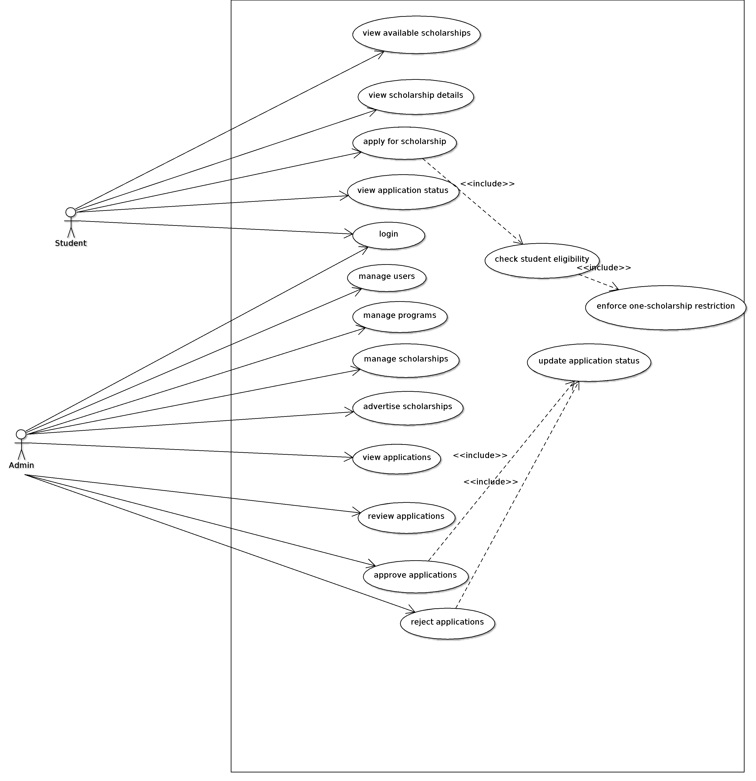
Figure 1: Use case diagram of University Scholarship Management System (ArgoUML)

4.2 System Sequence Diagrams

4.2.1 SSD for UC-03: Apply for Scholarship (Ahmed Hassaan Gondal)
Inputs from student are show as message to System, and output are show as return messages.
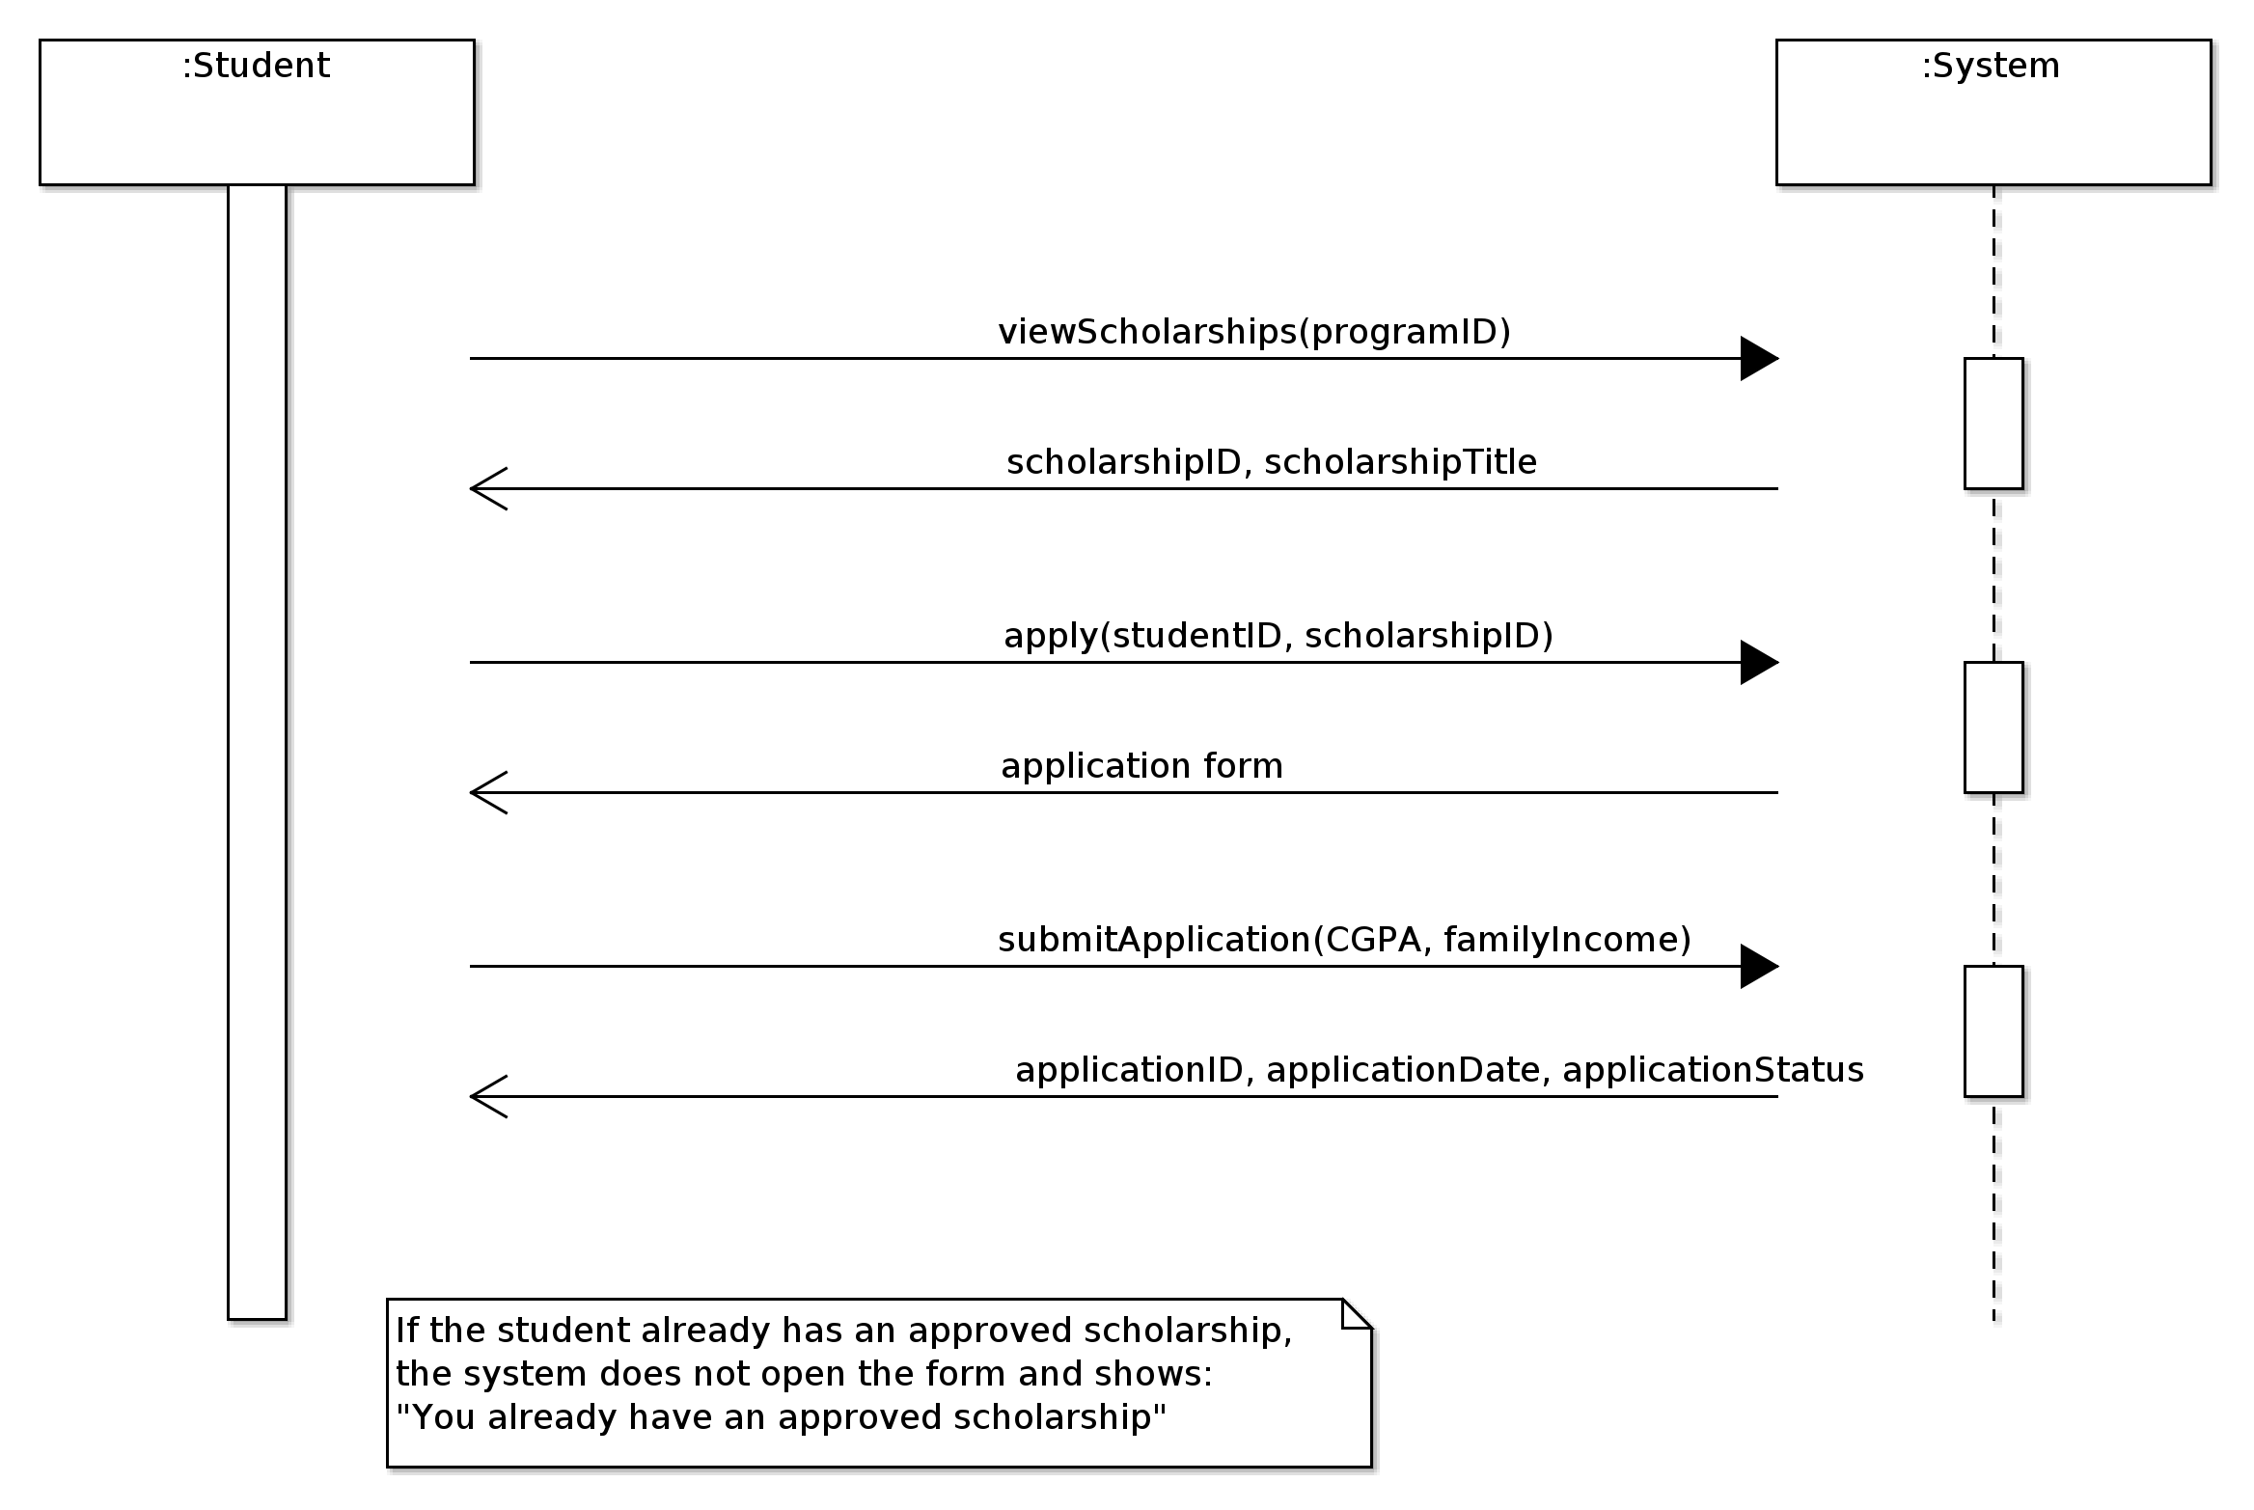
Figure 2: System sequence diagram for Apply for Scholarship (ArgoUML)

4.2.2 SSD for UC-09: Review Application (Muhammad Arslan)
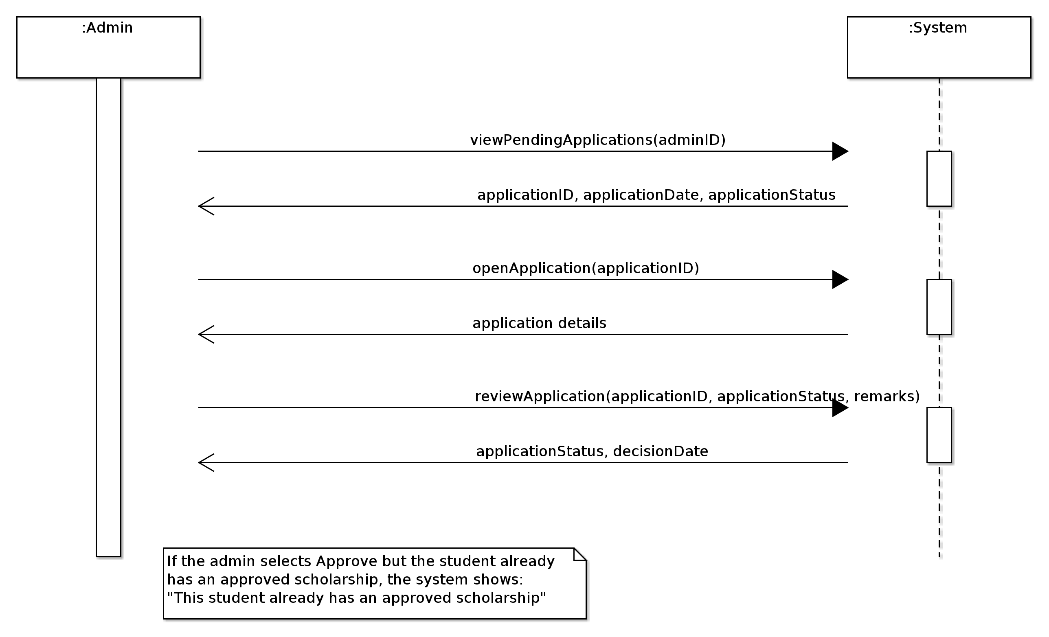
Figure 3: System sequence diagram for Review Application (ArgoUML)

4.3 Domain Model
Updated: new use cases need more data so we add eligibilityCriteria, numberOfAwards, closingDate and scholarshipStatus in scholarship, username and password in Admin and Student, and remarks and decisionDate in Application.
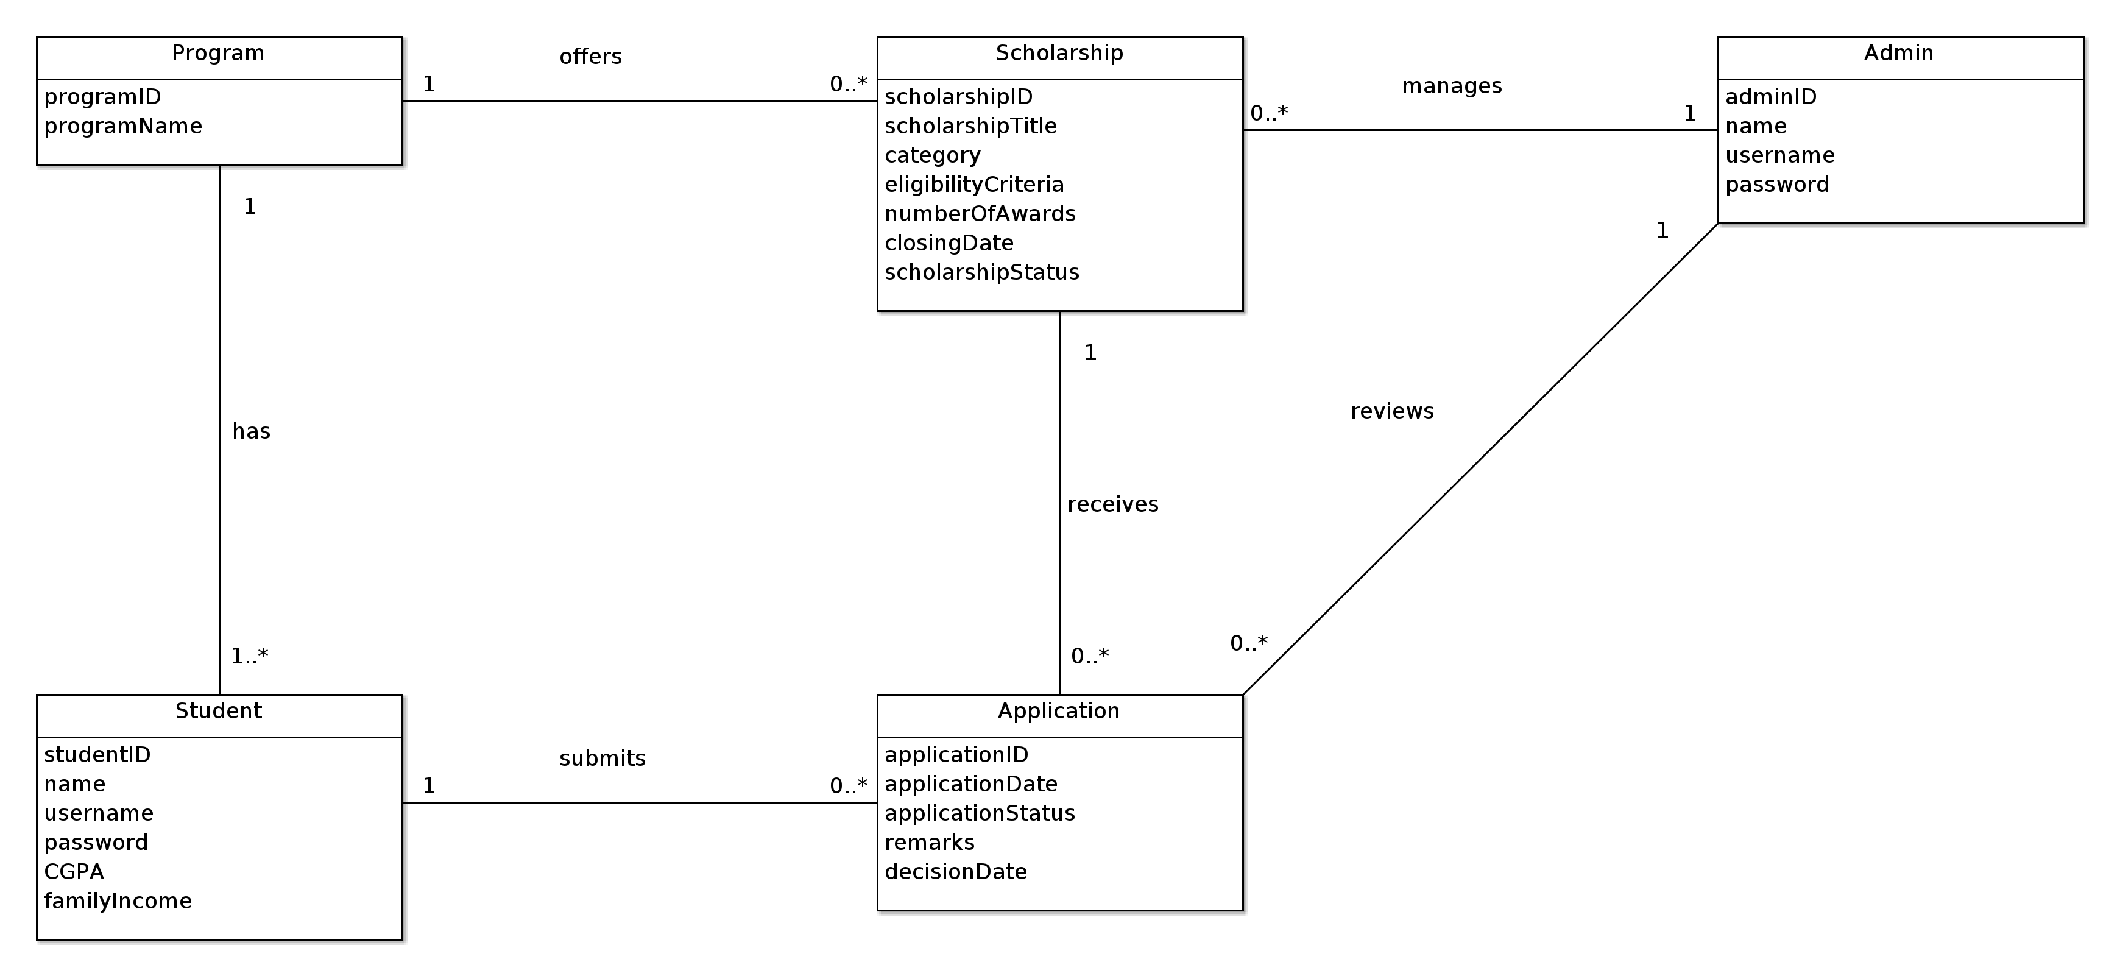
Figure 4: Domain model of University Scholarship Management System (ArgoUML)
Relationships:
• One Program offer many Scholarship. One Program have many Student.
• One Student submit no Application or many Application.
• One Scholarship get no Application or many Application.
• One Admin manage many Scholarship and review many Application.

